Setup link 🡪 <https://nodejs.org/en/>

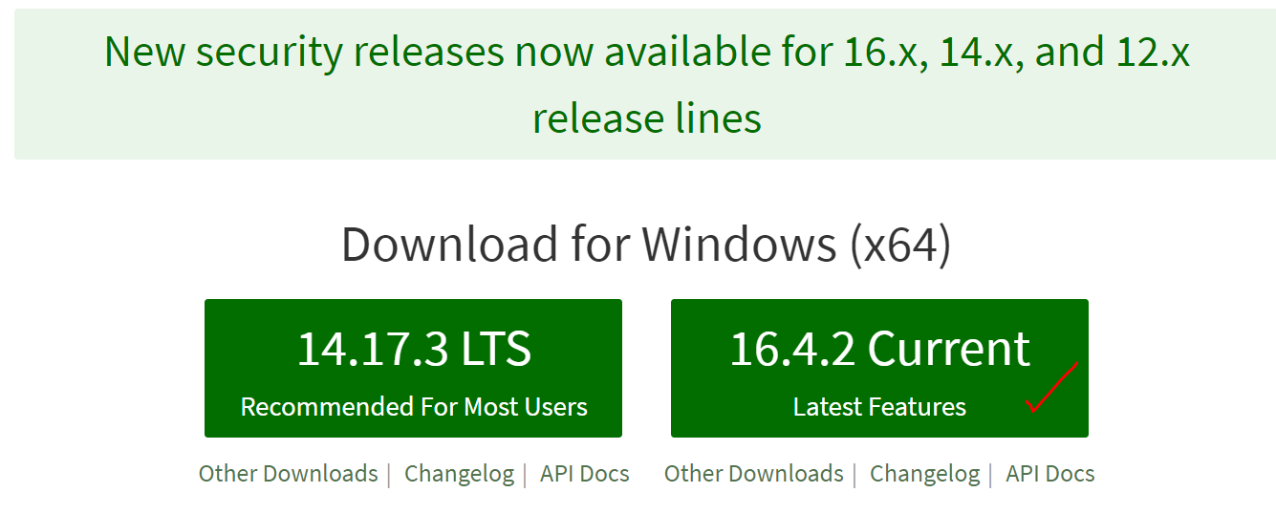

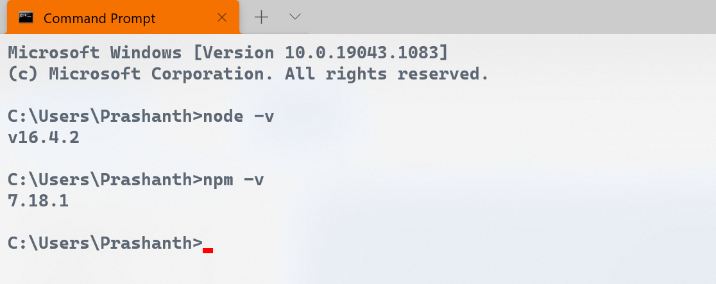

**Setting up package.json**

1. npm init

npm install lite-server –save-dev

Setting up a node module called lite server

Configuring our project with lite server

How the lite server enables to automatically see updates to our browser window as we make changes to the html files of our project ??

How to exclude some folders/files from being committed to the git repository?  
Using gitignore